Project Specification

Business Requirement

The following will be our deliverables:
- First the trader will have to login with his credentials which will take him to a screen with 3 tabs, Bond static maintenance tab being the first one active by default,which contains the reference data.
- A reference data of all the maintained bonds with its attributes such as -
- ISIN
- coupon rate and coupon period
- bond description,
- start date and maturity date,
- piece size unit amount
- currency.
The trader will have the option to search for the bonds of his choice by using the filters of :-
- currency and
- coupon rate.
- He can then copy the ISIN number from here and proceed to next tab of Trade booking screen where he can paste the ISIN number.
- The trade booking screen will also give the option of selecting a particular bond using the ISIN drop down menu.
The moment the ISIN number is chosen ,the corresponding fields pertaining to all the other details of that particular bond get populated automatically.
- The trader then has to input-
- Settlement Date and
- Anticipated yeild,
while our application will compute and populate the fileds of (Read Only fields)-
- Clean Price
- Dirty Price
- Accrued Amount
- Settlement Amount
This tab lets the trader to queue up his requests which might be processed later.
- The third tab of Trade Blotter Screen will display all the booked trades and the relevent deatails.This screen provides the trader with the option of sorting his trades as per-
- Time of booking
- maturity date

Technical Plan

Front End Middle layer Back end
GUI .........................> JAVA ............................> ETL

- (C#, WPF) (Java, JNDI, JDBC) (Visual Studio)
(REST, EJB ) ( MySQL workbench)

Screenshots

Trade Booker Screen
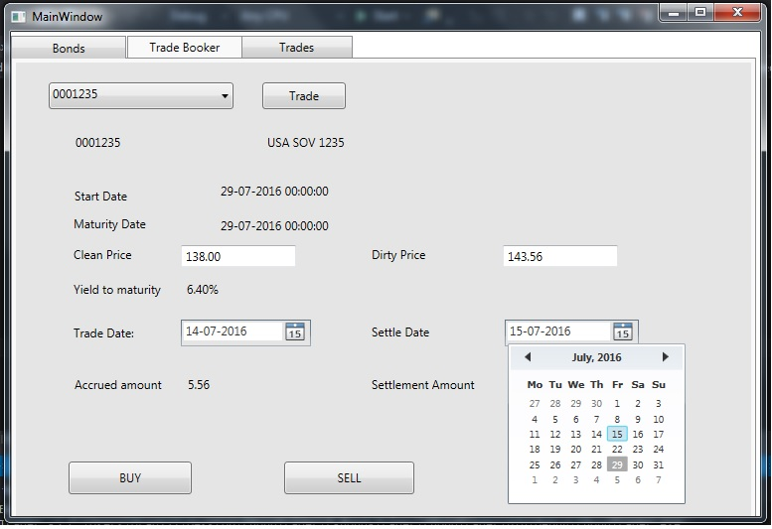

Trade Blotter Screen

